DBA ASSIGNMENT

Create a database
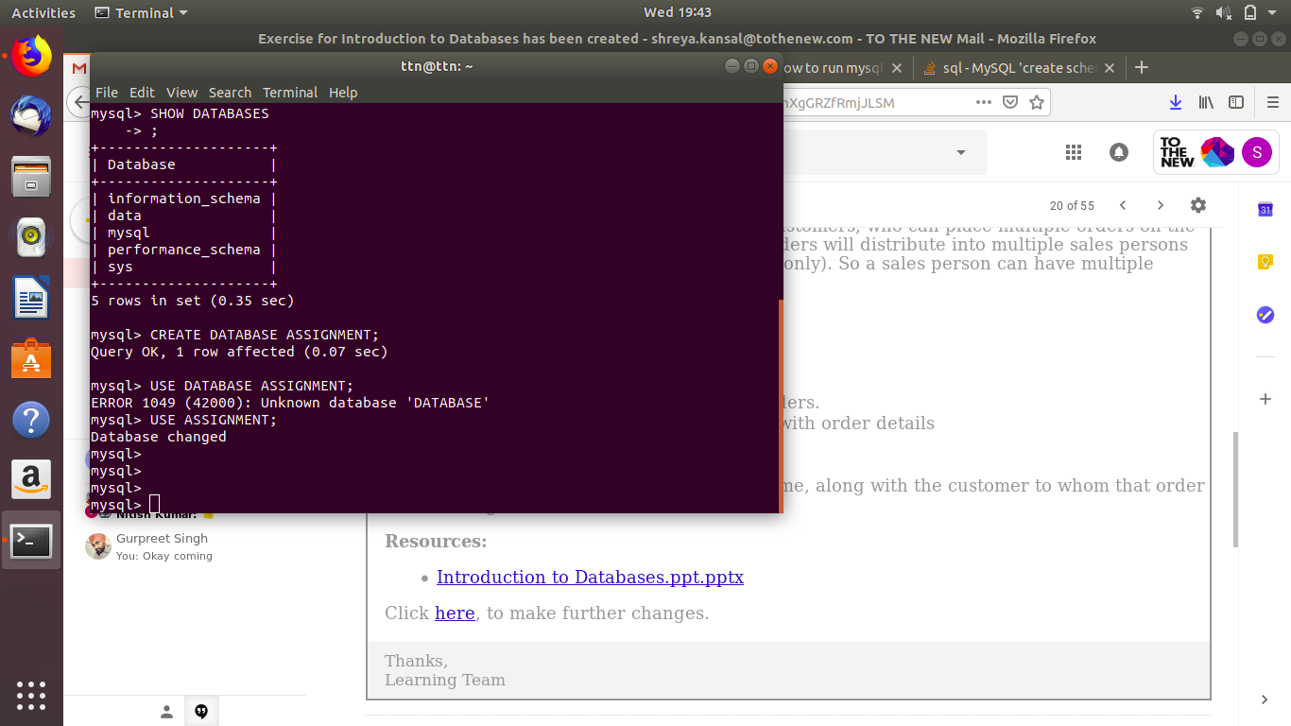
2. Design schema
table 1 CUSTOMERS

cid(primary key) | cname
1 | shreya
2 | bhavleen
3 | abcd

Table 2 SALES

SID(PRIMARY KEY) | sales_name
35 | chaman
43 | aman
53 | paman

Table 3 ORDER
oid(primary key) | Amount | cid(foreign key) | oid(foreign key)
13 | 1000 | 2 | 53
38 | 31000 | 1 | 35
35 | 54000 | 3 | 53

3. Create tables

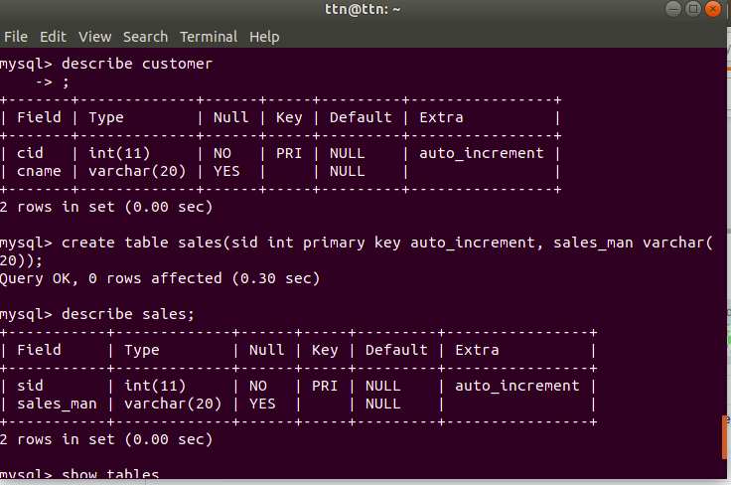

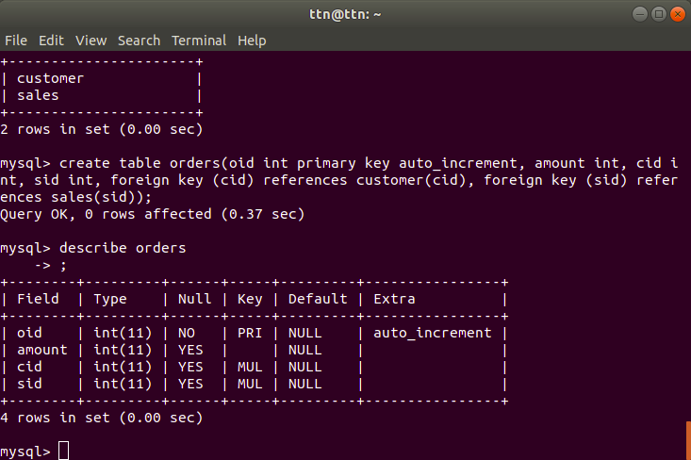

4. Enter sample data
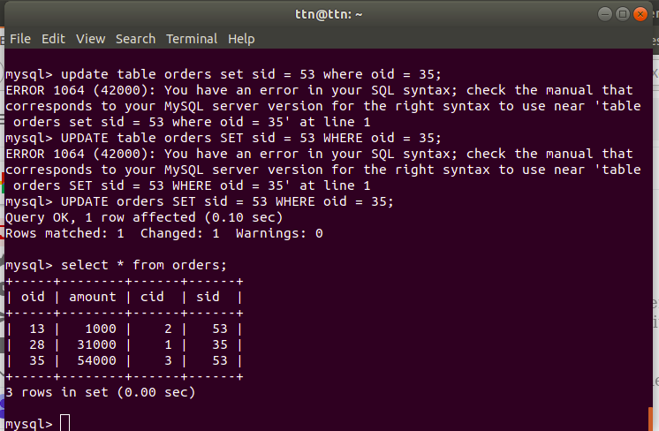

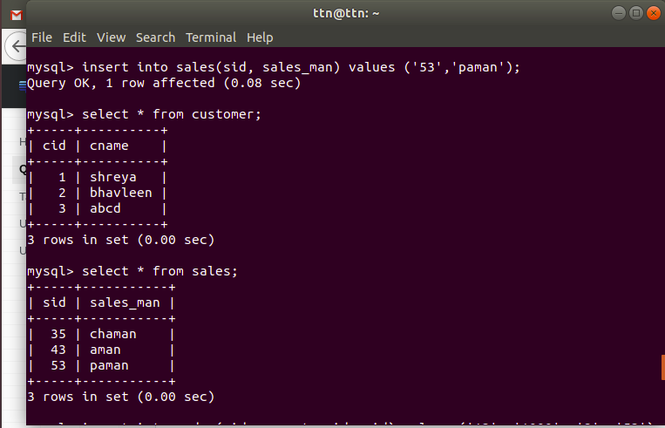

5. Find the sales person have multiple orders.

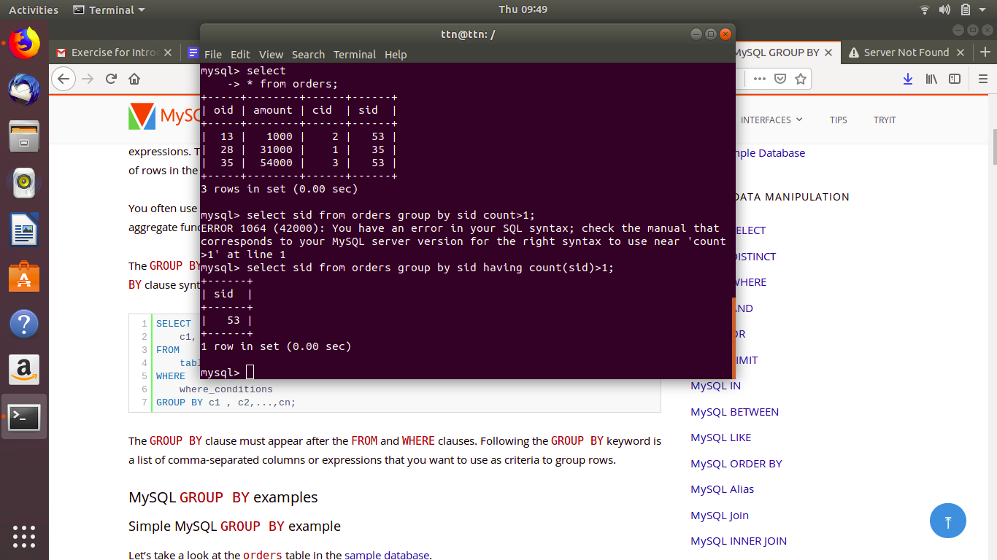
6. Find the all sales person details along with order details

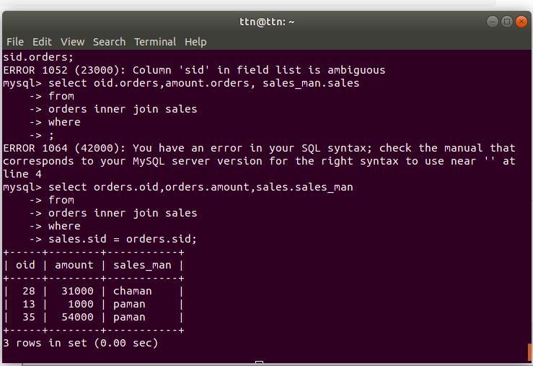

7. Create index

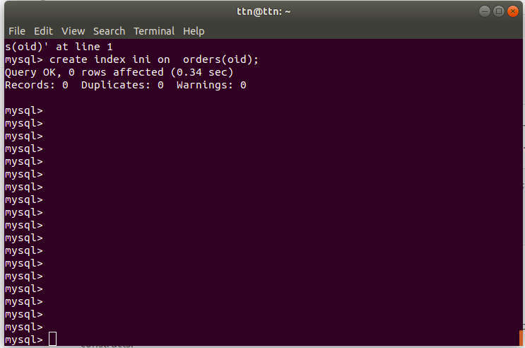

8. How to show index on a table

